**Project Skills and Professionalism**

**Problem Statement:**

The task at hand involves creating a software solution for managing a Rugby Club. This involves various functionalities such as reading data from files, sorting, searching, adding players, and generating random players.

**Key Challenges:**

|  |  |
| --- | --- |
| **Challenge** | **Description** |
| **Data Management:** | Efficiently managing data about club members, including their names, coach types, and team names. |
| **Sorting:** | Implementing a sorting algorithm to organize club members alphabetically by name. |
| **Searching:** | Developing a search algorithm to find club members by name. |
| **User Interaction:** | Providing a user-friendly interface for adding new players and interacting with the program. |
| **Scalability:** | Ensuring the program is scalable to handle potential future expansions of the rugby club. |

**Requirements:**

* Read data from file.
* Sort club members alphabetically by name.
* Search for club members by name.
* Add new players with coach types and team names.
* Generate random players with unique combinations of name, coach type, and team name.
* Provide a user-friendly interface for user interaction.

**Solutions and Rationale**

|  |  |  |
| --- | --- | --- |
| **Challenge** | **Solution** | **Rationale** |
| **Data Management** | Utilizing object-oriented programming principles to create a Person class to represent club members with attributes for name, coach type, and team name. | This approach organizes data efficiently and allows for easy manipulation and access. |
| **Sorting** | Implementing the Merge Sort algorithm for sorting club members alphabetically by name. | Merge Sort offers stable performance with a time complexity of O (n log n) making it suitable for sorting large datasets like the club members' list. |
| **Searching** | Implementing Linear Search for searching club members by name. | Linear Search is simple to implement and suitable for the relatively small dataset expected in this context. However, for larger datasets, other search algorithms like Binary Search could be considered for improved efficiency. |
| **User Interaction** | Providing a menu-driven interface allowing users to choose options like sorting, searching, adding players, and generating random players. | This approach offers clear and intuitive interaction, guiding users through available functionalities. |
| **Scalability** | Designing the program with modular and scalable architecture, separating concerns like data management, sorting, searching, and user interaction into distinct components. | This design allows for easier maintenance and future expansions of the program, accommodating potential growth in the rugby club. |

**Strengths:**

* Clear and modular design facilitates maintenance and scalability.
* Efficient sorting and searching algorithms ensure optimal performance.
* User-friendly interface enhances usability and accessibility.

**Weaknesses:**

* Linear search may become inefficient for larger datasets, requiring consideration of alternative search algorithms.
* The program's scalability may be limited by the chosen implementation choices, potentially requiring redesign for significant expansions.

**Alternative Approaches:**

**Sorting Algorithm:** Instead of Merge Sort, Quick Sort could be considered for potentially better average-case performance. However, Quick Sort's worst-case behavior may pose a risk.

**Searching Algorithm:** Binary Search could be chosen over Linear Search for improved efficiency, especially for larger datasets. However, it requires the data to be sorted beforehand, adding complexity.

**User Interaction:** A graphical user interface (GUI) could be developed for enhanced user experience, though it may require additional development effort.

**Problem definition and mapping diagram**

A mapping diagram will visually represent the relationship and interactions between the different components of the Rugby Club program, including data management, sorting, searching, user interaction, and scalability.

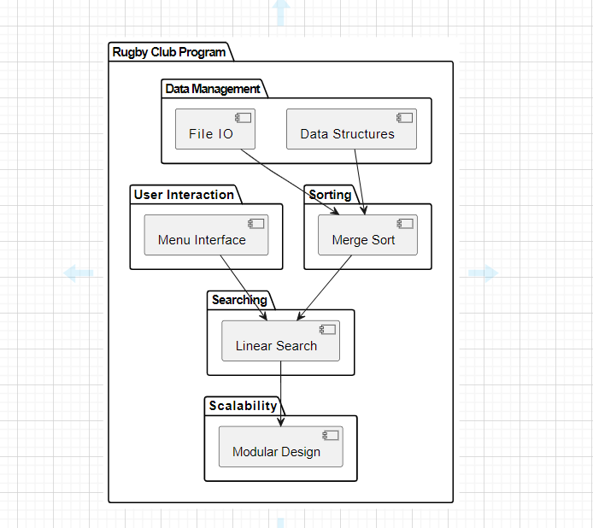

* Data structures and file I/O operations feed into the sorting component, indicating that data from files is managed and then sorted using Merge Sort.
* Both sorting and the menu interface interact with the searching component, suggesting that sorted data can be searched through the menu interface.
* Finally, the Linear Search component interacts with the modular design aspect of scalability, indicating that the search functionality is designed to be modular and scalable.

**Risk Assessment**

|  |  |  |
| --- | --- | --- |
| **Risk** | **Description** | **Solution** |
| Data Integrity Risk | There is a risk of data corruption or loss during file I/O operations. | Implement error handling and data validation mechanisms to ensure data integrity.  For example, validate input data formats and handle file reading errors gracefully. |
| Performance Risk | Sorting and searching algorithms may not perform optimally for large datasets, impacting program performance. | Choose algorithms with reasonable time complexities and implement optimizations where possible.  For example, use Merge Sort for sorting as it has a time complexity of O (n log n), which is efficient for large datasets.  Additionally, consider implementing binary search for searching, which has a time complexity of O (log n) for sorted data. |
| User Error Risk | Users may input incorrect data or misuse the program, leading to unintended outcomes. | Provide clear instructions and error messages to guide users through interactions with the program. Implement input validation to prevent invalid data entry.  For example, validate user inputs for adding new players to ensure  they are within acceptable ranges. |
| Scalability Risk | The program may not scale effectively to handle potential future expansions of the rugby club. | Design the program with modularity and scalability in mind.    Separate concerns into distinct components, such as data management, sorting, searching, and user interaction, to facilitate future modifications and expansions.  Additionally, use data structures and algorithms that can handle larger datasets efficiently. |